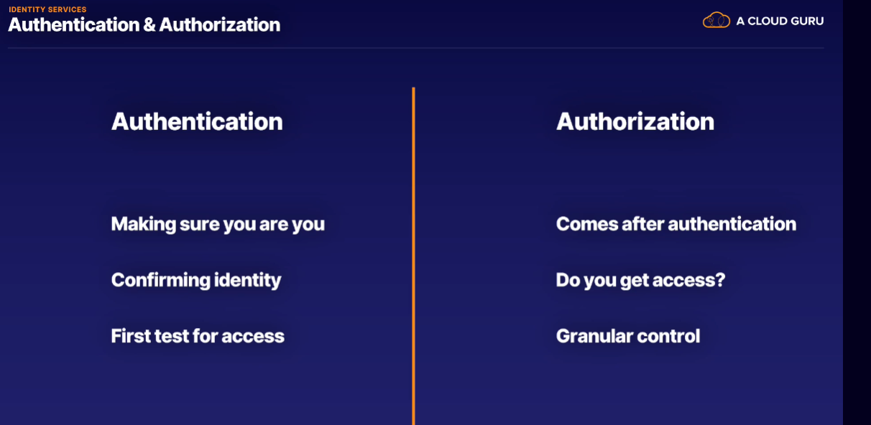

** Active Directory is not same as Azure Active directory

Active Directory is a Microsoft product for on premises identity verification

Azure Active Directory is used in cloud for identity verification

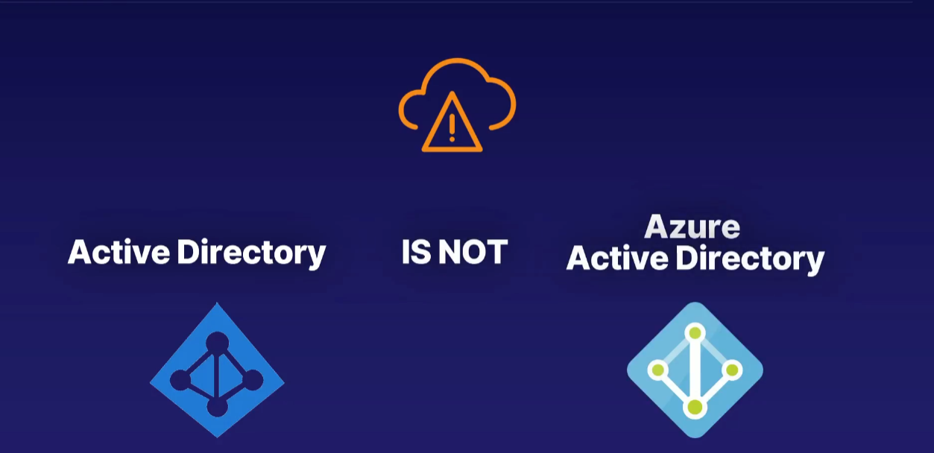

Azure Active Directoty

* You can't have an Azure account without an AAD service.
* Every Azure account has to have a first user and owner, and that user needs to be in an Azure Active Directory instance.
* So the first thing you get when you create a new Azure account is an AAD service or instance.

Tenant

* A tenant represents the organization
* A tenant is a dedicated instance of Azure Active Directory, which is the first AAD instance that is created when a user signs up for Azure or another Microsoft Cloud service.
* Each Azure AD tenant is distinct and separate from other Azure AD tenants.
* A user belongs to a tenant and only 1 tenant.
* All users in Azure are part of an AAD instance but can also be guests in others. This means that while a user belongs to a single tenant, they can be guests of others.

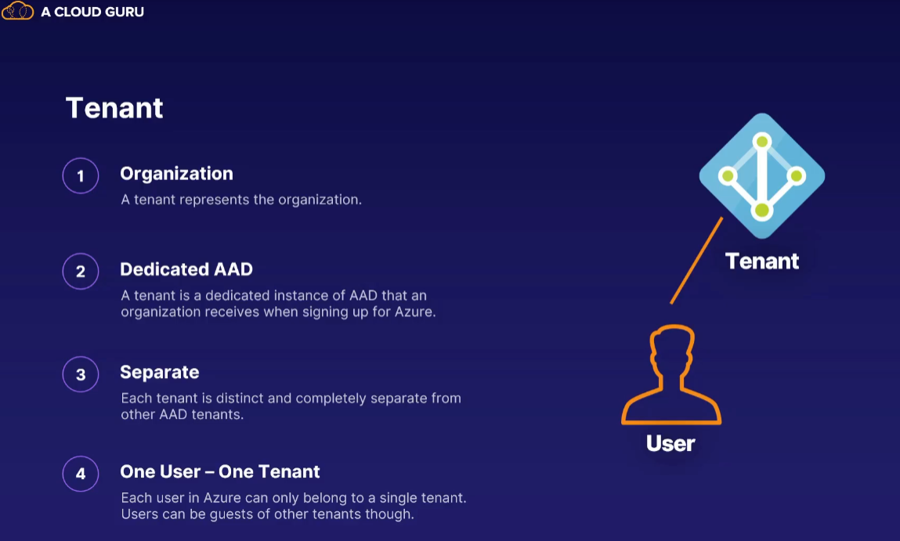

Subscription

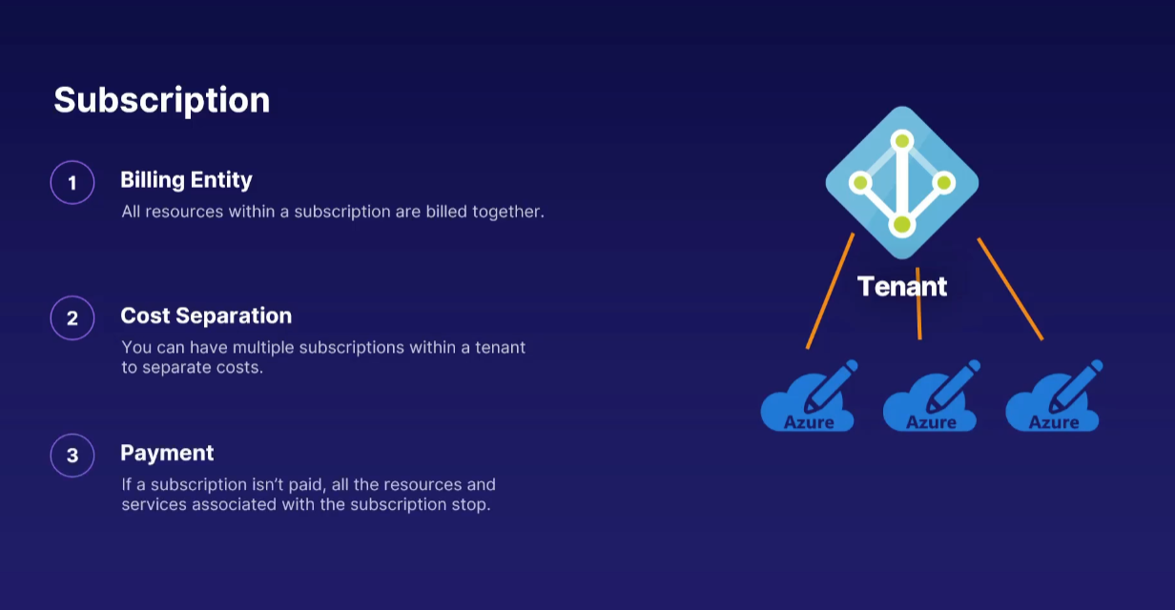

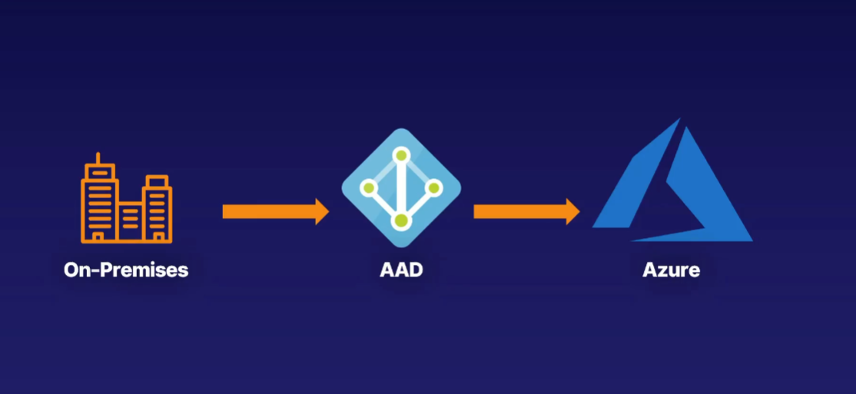

In a hybrid cloud architecture, you have some services on-premises and some are hosted in Azure.

AAD can help manage your users both in the cloud on Azure and on your premises.

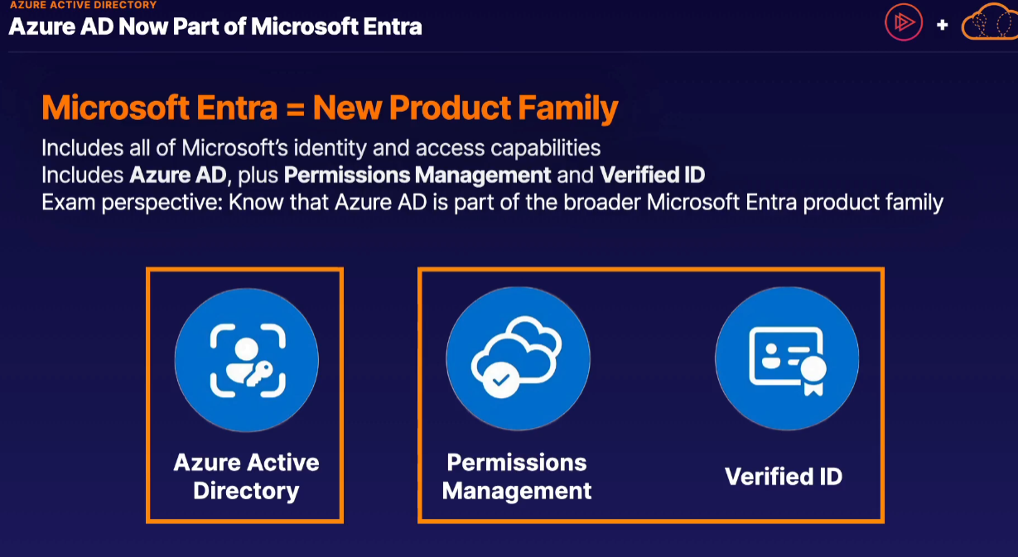

Azure AD is part of the new Microsoft Entra product family, which includes Azure AD as well as other services.

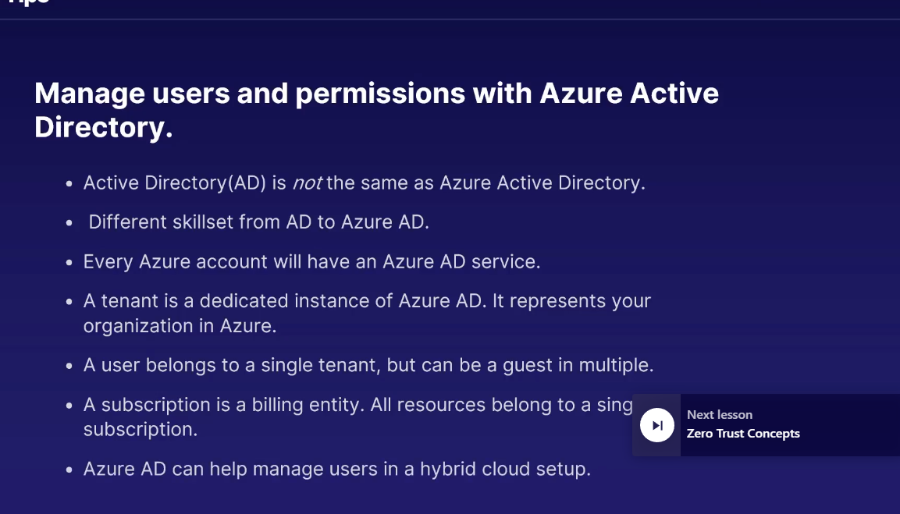

Zero Trust Concepts

Zero Trust is not a specific Azure service. Rather, it is more of a security philosophy, or a model, that really shapes how modern work-from-anywhere authentication works.

Inside of your corporate network at the corporate office, we've been able to restrict access to private or sensitive materials to entities or devices inside of that secure network.

In other words, if you're on the internal corporate network, you have a higher level of trust to those sensitive resources.

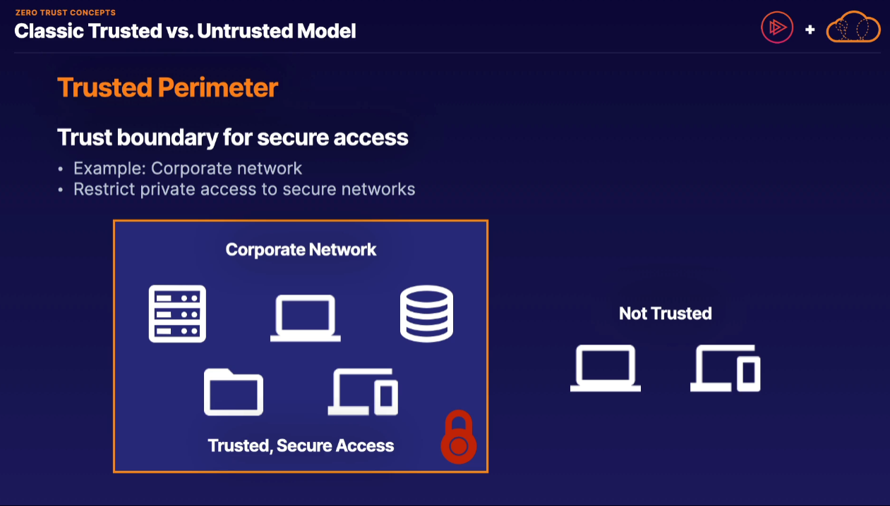

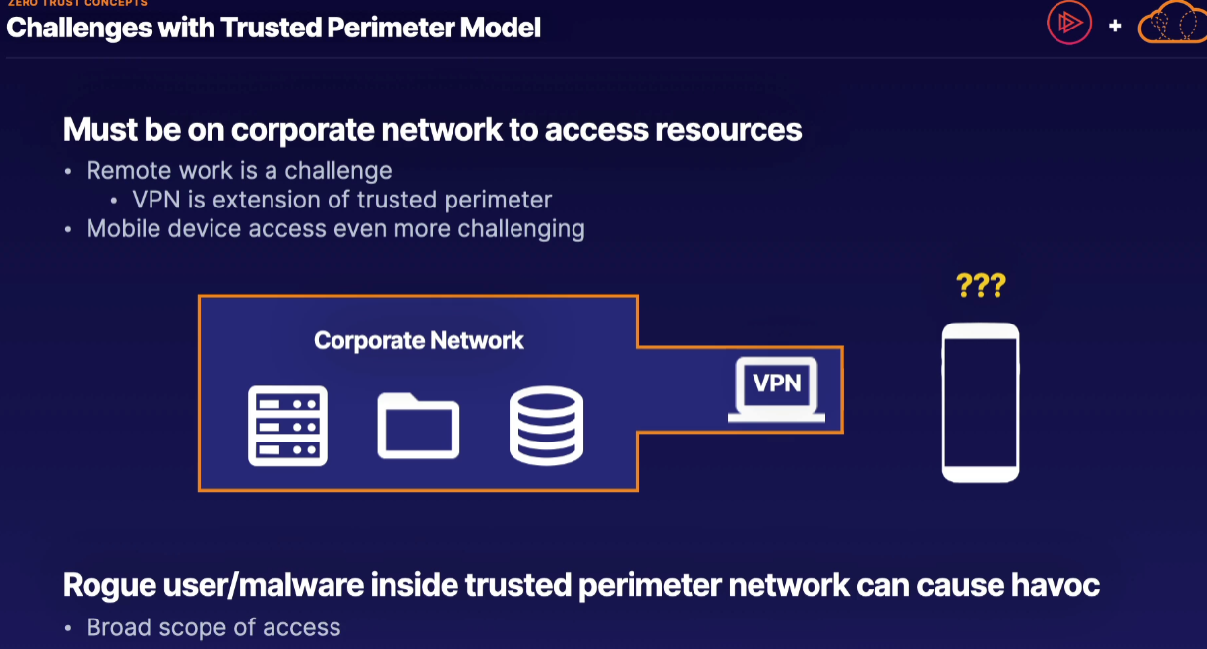

So then Zero Trust will come into picture

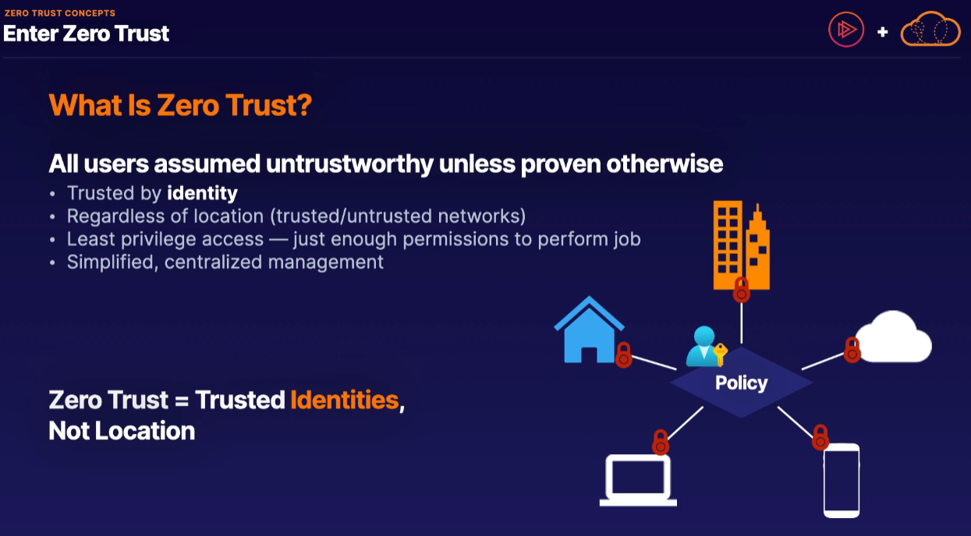

**** think of Zero Trust as trusted identities as opposed to trusted locations.

**** Proving your identity is the key to accessing sensitive resources, regardless of where you are located at.

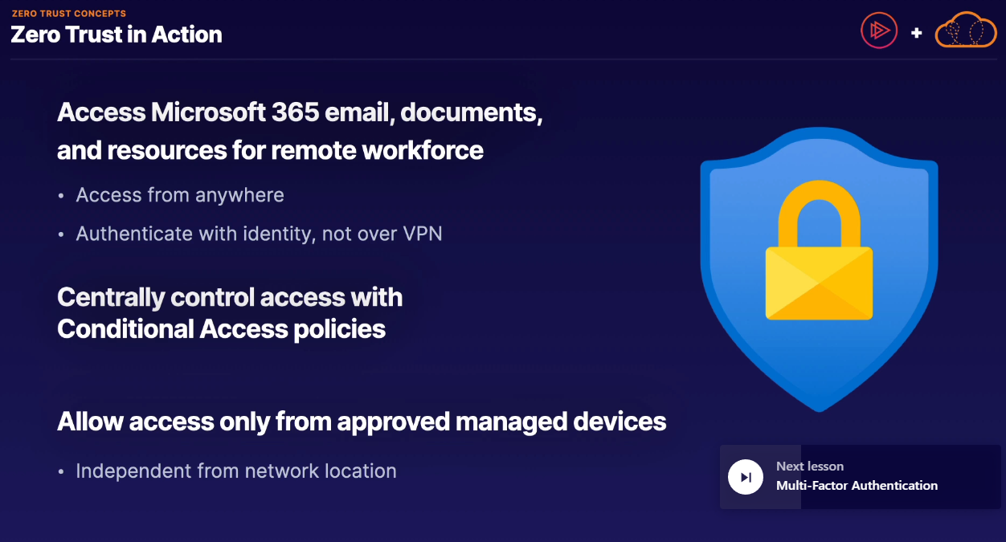

Multi Factor Authentication

Multi-factor authentication (MFA) is a security measure that requires users to provide two or more pieces of evidence to access a website or application.

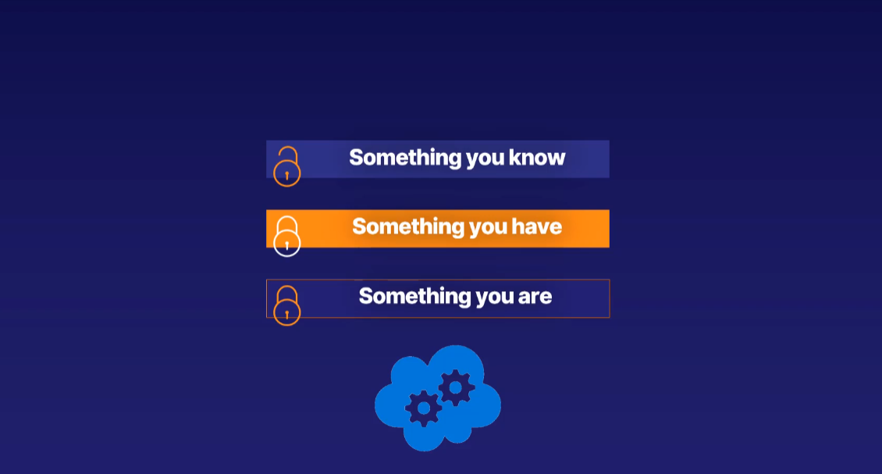

Something you know, which is almost always a username and password.

Something you have, such as an app on your phone or a key fob.

Something you are, meaning a fingerprint or retina scan, for example. Biometrics, in other words.

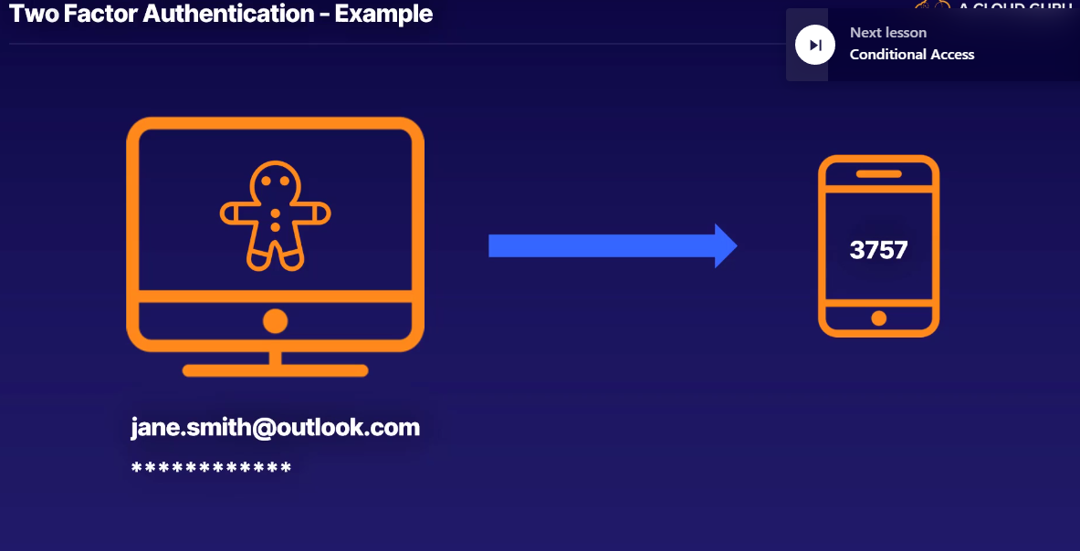

Conditional Access Concepts:::

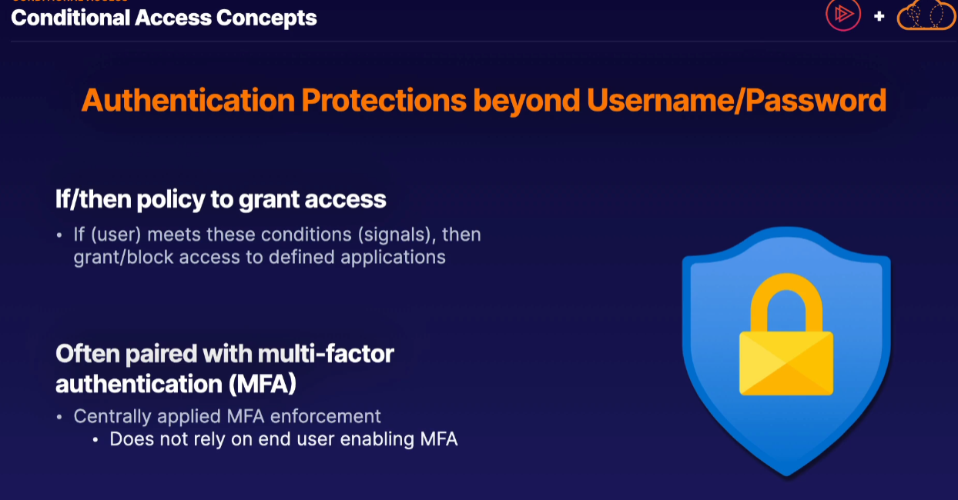

MFA is automatically enabled for all users

Conditional Access policies are a premium feature built into Azure Active Directory, which provide different authentication protections beyond simply supplying a username and password. In addition to requiring a username and password, Conditional Access policies also used if/then policies in order to grant access. In other words, once a user signs in, if that user account meets a preset set of conditions, or in other words, signals, then we can either choose to grant or block access to different defined applications.

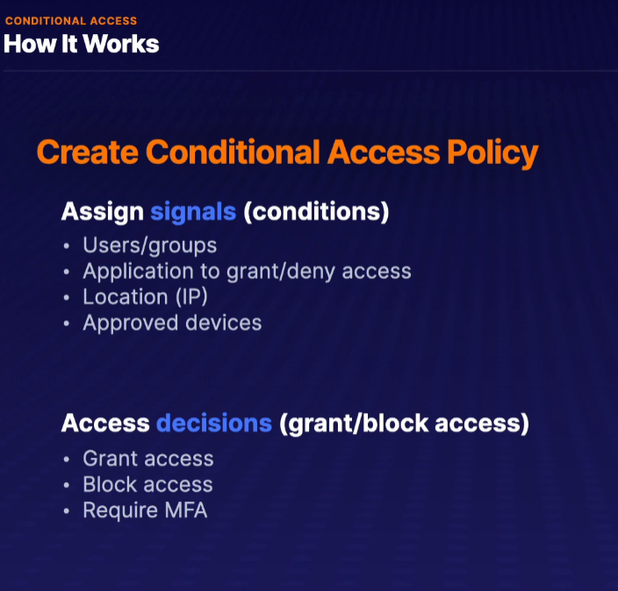

Here are some conditions for example

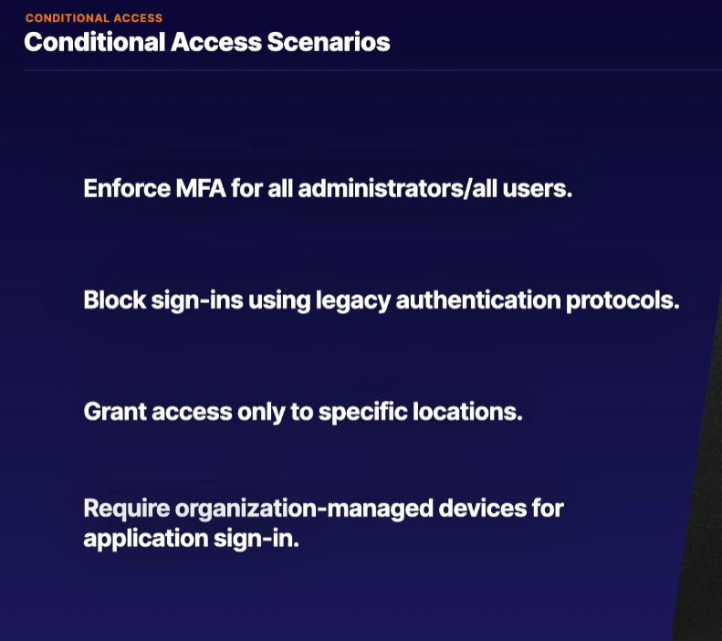

Passwordless Authentication::

The more the security steps, the convenience is less

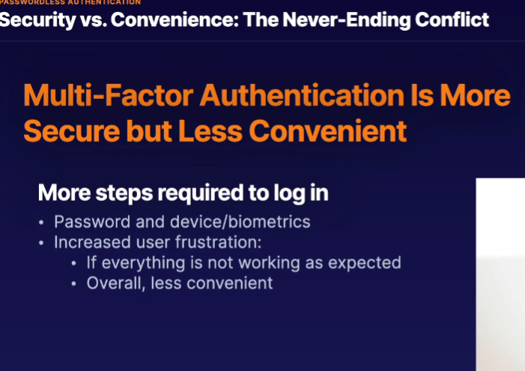

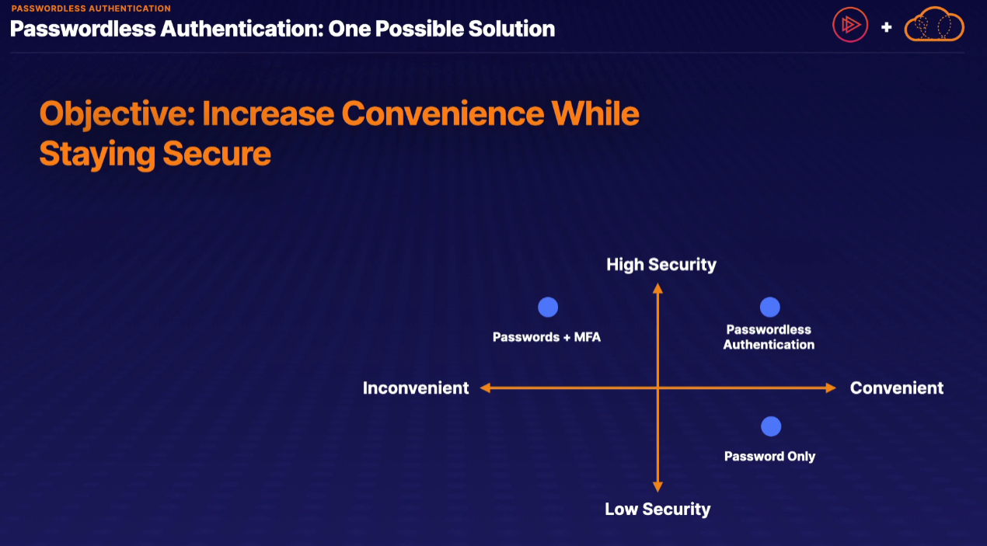

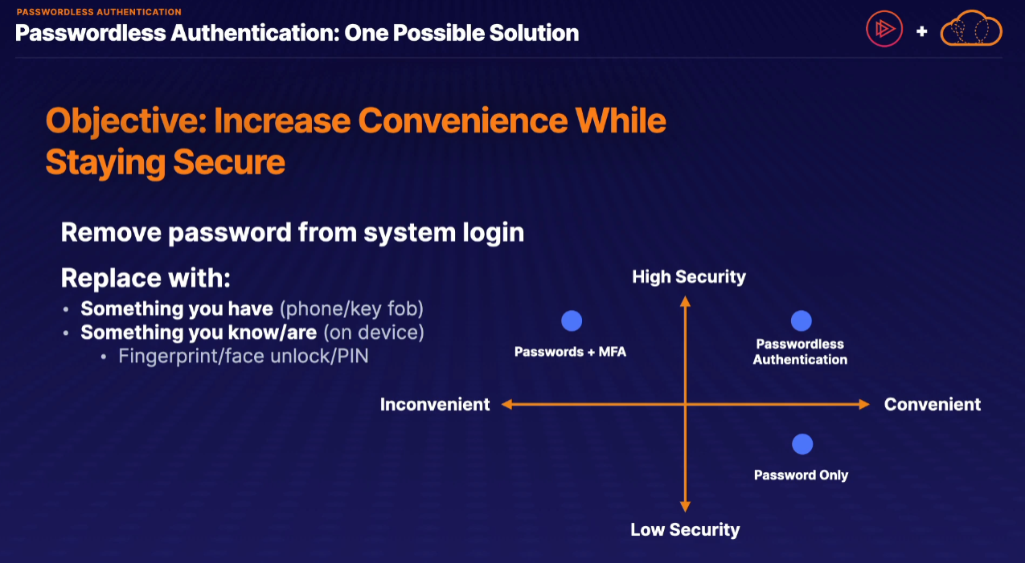

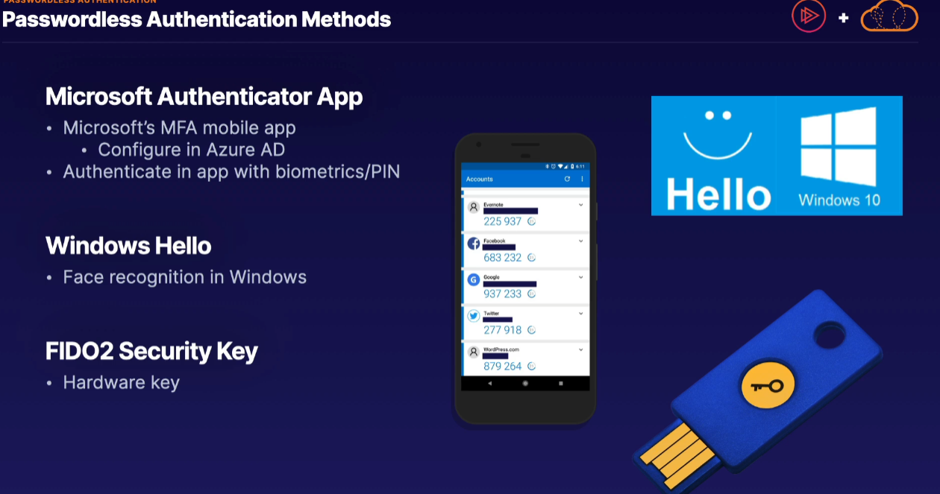

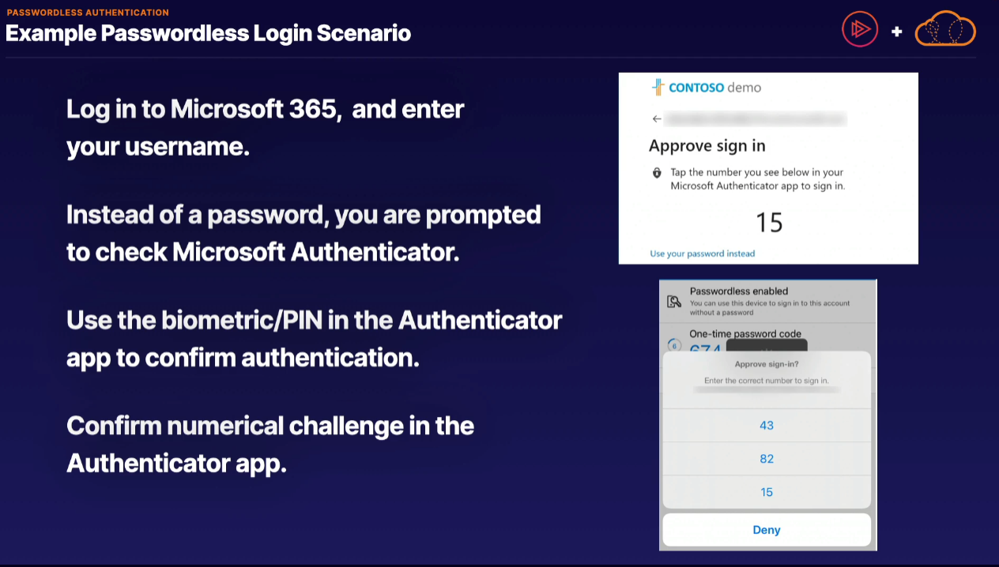

External Guest Access:::

We're focusing on in this lesson is how do we properly and securely collaborate with users not part of our organization?

Typical scenario would be that of working with some sort of an outside consultant to help streamline either our Azure or Azure Active Directory configuration and processes.

When it comes to inviting them into our internal organization, we have a couple different solutions available.

One possible solution is to create a separate internal organization account for our external user to temporarily use. Now, this is a perfectly valid and acceptable solution. However, it does come with the side effect that this external user now has to juggle 2 completely separate accounts: the primary account they've always been using and this separate internal account to use as well.

In doing so, our guest external user can simply use their existing account however configured as an external collaborator, and this process in Azure is referred to as **B2B** or business to business collaboration.

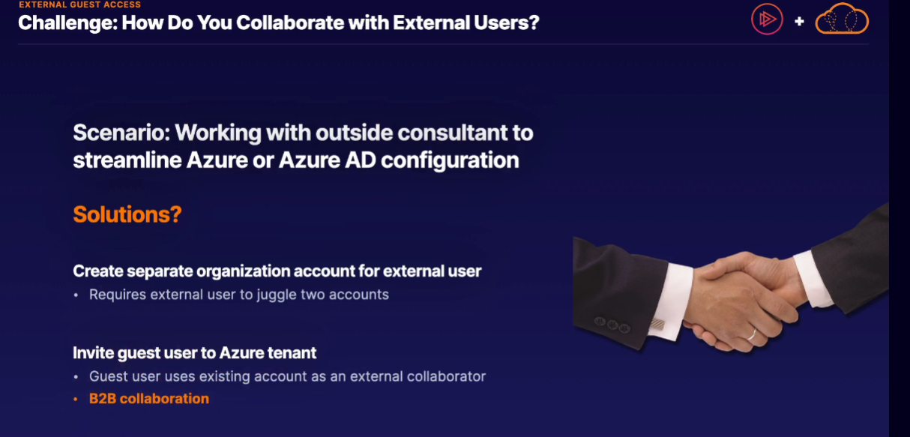

How to invite external user????

* We have to first invite your external user.
* fortunately, Azure Active Directory by default is able to invite a variety of account types
* commonly referred to as identity providers, of which some of the preconfigured identity provider accounts include Microsoft, Google, and Facebook accounts.
* If our external user is a Google account or a Facebook account or an Azure AD account, we can easily bring these accounts in with that identity provider.
* 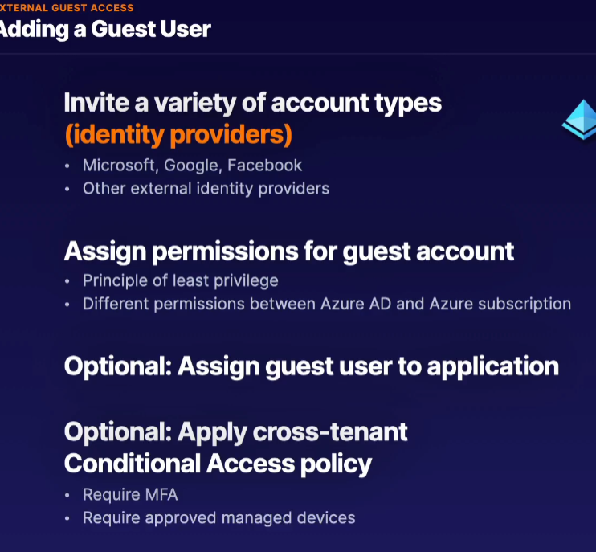

**Azure Active Directory Domain Services**

One of the largest barriers to full cloud adoption is in how to properly integrate older applications with modern cloud services.

Single Sign-on

If you want to use just one username and password to log in to multiple applications, you can use single sign-on in Azure.

Full name of this service is Azure Active Directory Seamless Single Sign-On.

Summary:::::

